Report on African Street Literature trip to Nairobi 25th September – 07th October 2018

I hereby offer my thanks to the Forum for Africa Studies for its financial support in paying for my ticket and 6 nights’ accommodation. The trip, which was part observational and field research, part material collection, and part presentation of the African Street Literature research project at universities and institutes in the interests of developing future collaborations, was a great success.

I travelled with a doctoral student, Rodney Likaku, and my co-investigator on the project, Dr Nicklas Hållén. An outline of our trip follows:

26 September – Interview with Billy Kahora, chief editor of Kwani? magazine.
Interview with Hauron Risa and Peter Ngila Njeri, authors
Open Mic Session and material collection
27 September – Presentation by AH, NH and RL of project at Kenyatta University and discussion with the head of international affairs about a future memorandum of understanding.

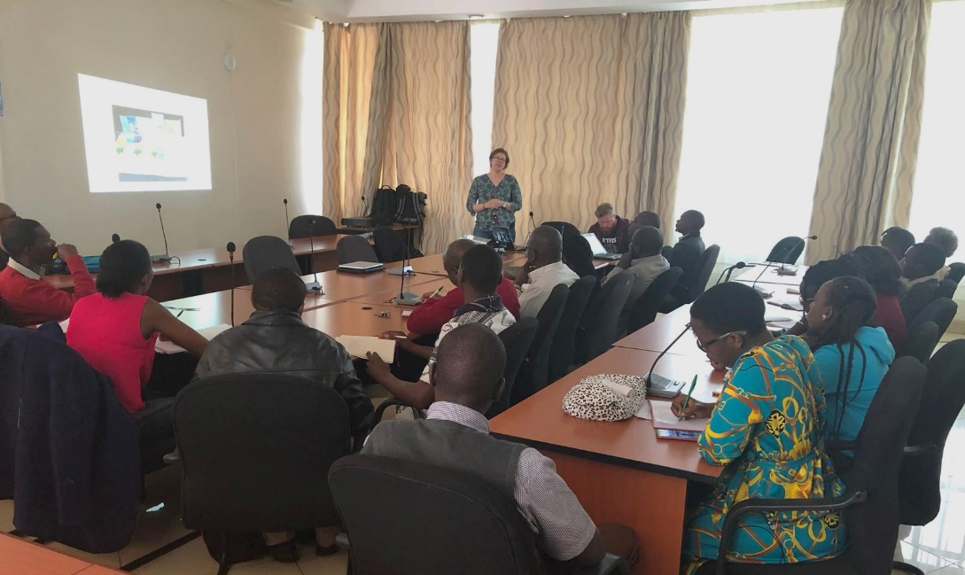

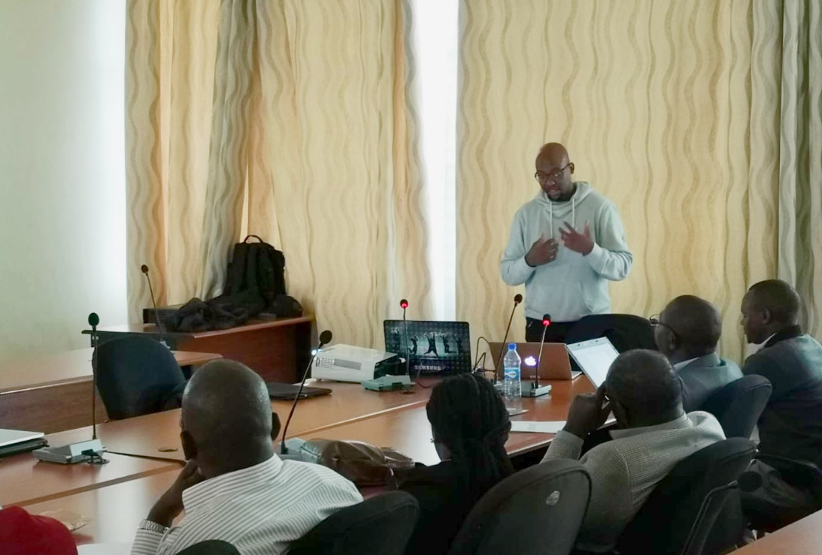

The presentation, which was organised by Dr Justus Makokha, was attended by over 25 research students and staff at the university.
RL interviewed doctoral students (future outcome: blog entries)

28 September – Attended 21st Nairobi International Book Fair (26-30 September 2018).
Interviewed author Sheila Bosire (Blog of interview available at: https://africanstreetliterature.blog)
Meeting with the Writers Guild (future outcome: various young
authors producing blog entries for African Street Literature)

29 September – Attended film screening of Rafiki, a film by Kenyan Director Wanuri Kahui at the Goethe Institut. The film is highly controversial because it tells the tale of two young lesbians. (Future plans: possibly get rights to show the film at the African Film group?)

30 September – Interview with organizer of Street Poetry Kenya, Poppa Steve-O. (future outcome: blog)

01 October – Trip to the GoDown Arts centre
Interview with author Stanley Gazemba (future outcome: blog on African street literature)

02 October – Visit to Kwani? Material collection and meeting with critic and editor Otieno Owino and sales manager Mike Mburu (future outcome: Owino to contribute to special edition of NJAS).

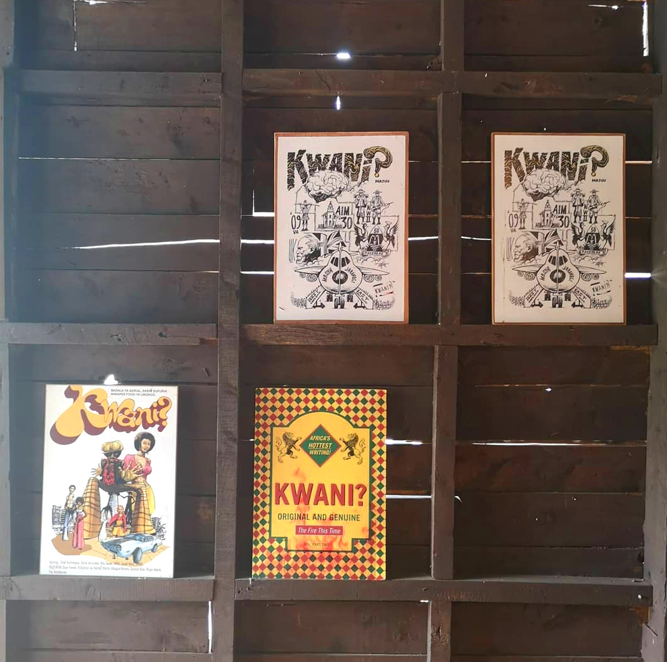

03 October – Presentation by AH, NH and RL of project to the Department of Literature at the University of Nairobi. Organised by Dr Tom Odhiambo. 20 people in attendance (see pictures below). Outcome: discussion of collaboration with Dr Miriam Wangu Maranga Musonye, who has an established project with Humboldt University. Possible collaboration on future application for funding –ERC).

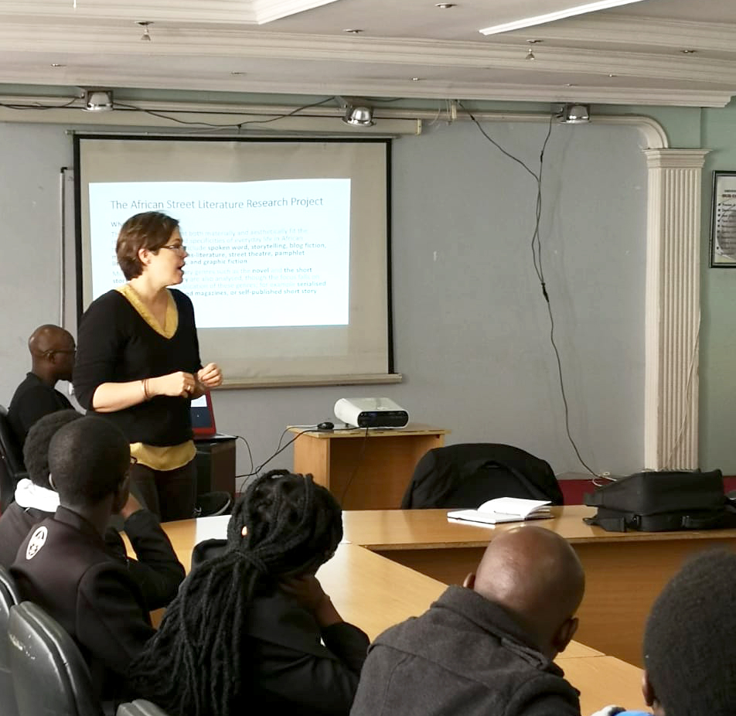

Visit to the British Institute of Eastern Africa. Meeting with country director, Dr. Freda Nkirote, who indicated interest in future affiliations. Meeting with researcher Dr. Doseline Kiguru (future outcomes: Kiguru to contribute to special edition of Journal of East African Literature, Kiguru to apply for research stay at NAI).

Visit to Pawa 245, an activist art center which hosts spoken word poetry and other literary events and provides infrastructural support for young artists and activists. Met with Gibson Maina, who runs the ‘emerging voices’ program.

4 October – Trip to the Goethe Institute for material collection
Interview with spoken word poet Patrick Lavince (future outcome, blog entry)

5 October – AH and NH leave, RL presents project and his own research at the British Institute in Eastern Africa (see images below).
RL to attended spoken word event at Pawa254.

